

SIMATS ENGINEERING
Saveetha Institute of Medical and Technical Sciences
Chennai 2026
ASSESSMENT TOOL -1
CO2_AT1

Name : P Giriprasad Reddy
Register No : 192525172
Course code : CSA1016
Course name: Software Engineering
Faculty name: Anitadavamani K

Scenario-Based Requirement Analysis

Safe Route AI: Intelligent Road Hazard Detection and Accident Prevention System

1. Introduction
Road accidents are one of the leading causes of injuries and fatalities worldwide. Many accidents occur because drivers are unaware of road hazards such as potholes, fallen trees, waterlogging, construction zones, roadblocks, or unexpected obstacles. Traditional navigation systems mainly provide traffic updates but do not offer intelligent hazard detection and prevention.
Safe Route AI: Intelligent Road Hazard Detection and Accident Prevention System is an AI-powered solution designed to improve road safety through real-time detection of road hazards. The system uses computer vision, artificial intelligence, GPS, and cloud technologies to identify hazards and instantly notify drivers. By providing early warnings and recommending safer alternative routes, SafeRoute AI helps reduce accidents, improve traffic flow, and support road maintenance authorities.

Objectives of the Proposed System
- Detect road hazards automatically using AI.
- Provide real-time alerts to drivers.
- Recommend safer travel routes.
- Reduce road accidents and traffic congestion.
- Maintain a centralized database of reported hazards.
- Support road maintenance authorities with accurate hazard information.

2. Problem Description
Road accidents are increasing due to poor road conditions, unexpected obstacles, and the lack of timely hazard warnings. Drivers often encounter potholes, waterlogging, road construction, fallen trees, stray animals, or accident-prone areas without prior notice. Existing GPS applications mainly provide navigation and traffic updates but do not identify road hazards in real time.
SafeRoute AI addresses this issue by integrating Artificial Intelligence (AI), Computer Vision, GPS, and Cloud Computing to detect hazards automatically and provide instant alerts. The system captures road images using a camera, processes them using an AI model, identifies hazards, and recommends safer routes. This intelligent approach enhances driver safety and reduces the risk of accidents.

Problem Statement
Develop an AI-based road hazard detection system capable of:
- Detecting road hazards in real time.
- Alerting drivers immediately.
- Suggesting safer alternative routes.
- Maintaining a centralized hazard database.
- Assisting road authorities in monitoring and maintenance.

3. Scope of the System
The SafeRoute AI system focuses on improving road safety through intelligent hazard detection and accident prevention.

Scope
- Detect potholes, road cracks, waterlogging, and obstacles.
- Provide live alerts to drivers.
- Recommend safe alternative routes.
- Store hazard information in a cloud database.
- Allow users to report road hazards manually.
- Enable administrators to monitor reported hazards.
- Generate reports for road maintenance authorities.

Limitations
- Requires an active internet connection.
- AI accuracy depends on camera quality.
- Severe weather conditions may affect detection performance.
- GPS signal availability is required for navigation.

4. Business Domain
Domain: Smart Transportation and Intelligent Road Safety
The project belongs to the Intelligent Transportation System (ITS) domain, where Artificial Intelligence and IoT technologies are used to improve road safety, traffic management, and public transportation efficiency.

5. Stakeholders

Primary Stakeholders
- Drivers
- Passengers
- System Administrator

Secondary Stakeholders
- Traffic Police
- Road Maintenance Department
- Government Authorities
- Emergency Response Teams

Responsibilities
Stakeholder | Responsibility
Driver | Receives hazard alerts and follows safe routes
Administrator | Manages users and hazard database
Traffic Police | Monitors accident-prone areas
Road Authorities | Repairs reported hazards
Emergency Team | Responds to accidents quickly

6. System Objectives
The main objective of SafeRoute AI is to improve road safety using Artificial Intelligence.

General Objectives
- Reduce road accidents.
- Detect road hazards automatically.
- Provide instant hazard notifications.
- Improve driver awareness.
- Support smart transportation.

Specific Objectives
- Detect hazards using AI and Computer Vision.
- Recommend safer travel routes.
- Maintain a centralized hazard database.
- Improve emergency response time.
- Assist government agencies in road maintenance planning.

Expected Outcomes
- Fewer road accidents.
- Faster hazard reporting.
- Improved traffic management.
- Better driving experience.
- Enhanced public safety.

7. Functional Requirements
The system shall:
- Allow users to register and log in.
- Detect road hazards using AI.
- Track user location using GPS.
- Display real-time hazard alerts.
- Recommend safer alternative routes.
- Allow users to report new hazards.
- Send emergency notifications.
- Store hazard information in the cloud.
- Provide an administrator dashboard.
- Generate reports on detected hazards.

8. Non-Functional Requirements

Performance
- Hazard detection should occur within 2 seconds.
- Support multiple users simultaneously.

Security
- Secure user authentication.
- Encrypt sensitive user data.

Reliability
- Ensure 99% system availability.

Scalability
- Handle increasing numbers of users and hazard reports.

Usability
- Simple, intuitive mobile interface.

Maintainability
- Easy software updates and bug fixes.

9. Actors
Actors are the users or external systems that interact with the SafeRoute AI system.

Primary Actors
- Driver – Uses the application to receive road hazard alerts and navigate safely.
- Administrator – Manages users, hazard reports, and system maintenance.

Secondary Actors
- GPS Service – Provides real-time location data.
- AI Detection Module – Detects road hazards from captured images.
- Road Maintenance Department – Reviews reported hazards and schedules repairs.
- Emergency Services – Receives accident notifications when required.

Major Use Cases
Actor | Use Cases
Driver | Register, Login, View Hazard Alerts, Find Safe Route, Report Hazard
Administrator | Manage Users, Verify Hazard Reports, Generate Reports
AI Module | Detect Road Hazards
GPS Service | Provide Live Location
Road Authority | View Hazard Reports

10. Use Case Description

Use Case 1: User Login
Actor: Driver
Precondition:
- User has already registered.
Main Flow:
- User enters username and password.
- System validates credentials.
- User is successfully logged in.
- Dashboard is displayed.
Postcondition:
- User gains access to system features.

Use Case 2: Detect Road Hazard
Actor: AI Detection Module
Precondition:
- Camera and GPS are active.
Main Flow:
- Camera captures the road image.
- AI analyzes the image.
- Hazard is identified.
- Alert is generated.
- Hazard location is saved in the database.
Postcondition:
- Driver receives a warning notification.

Use Case 3: Report Hazard
Actor: Driver
Main Flow:
- Driver selects "Report Hazard."
- Uploads a photo (optional) and location.
- Submits the report.
- Administrator reviews and verifies it.

11. Data Requirements

Input Data
- User Registration Details
- GPS Coordinates
- Camera Images
- Hazard Reports
- Time and Date

Output Data
- Hazard Alerts
- Safe Route Suggestions
- Emergency Notifications
- Hazard Reports
- Analytics Dashboard

12. External Interface Requirements

User Interface
- Android Mobile Application
- Web-based Admin Dashboard

Hardware Interface
- Smartphone Camera
- GPS Sensor
- Internet Connection

Software Interface
- Python
- OpenCV
- YOLO Object Detection
- Google Maps API
- Firebase/MySQL Database

13. Software Tools

A. Jira
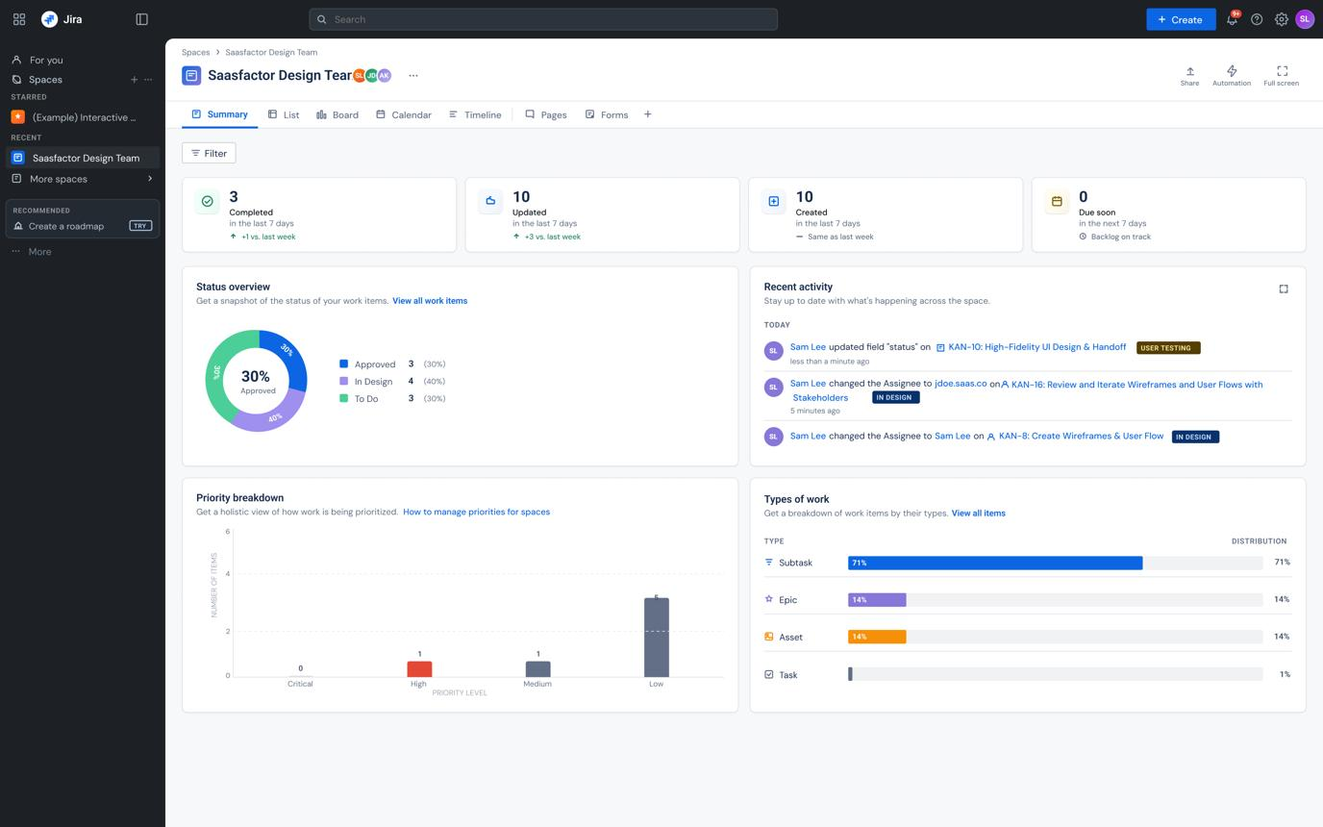
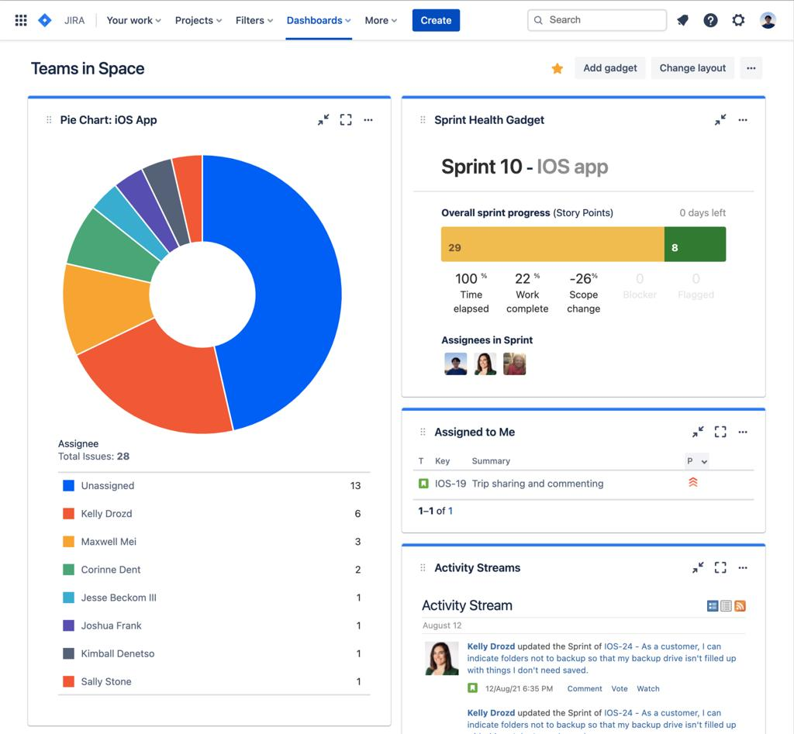
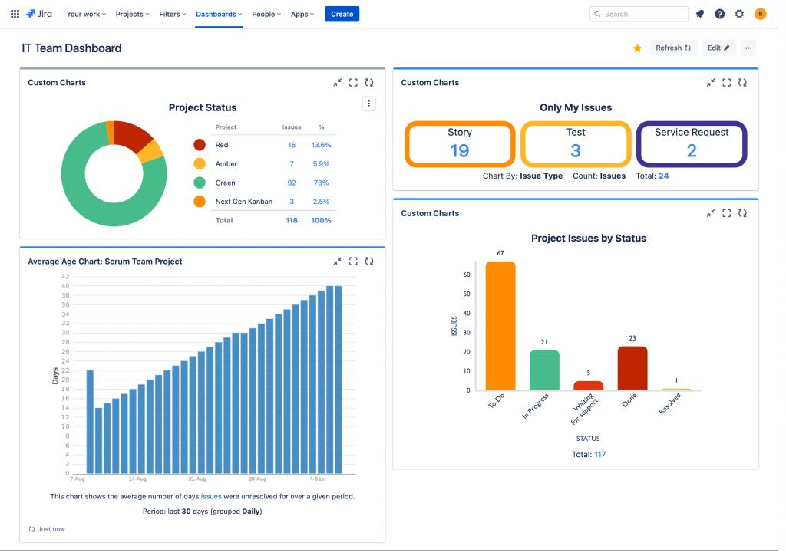

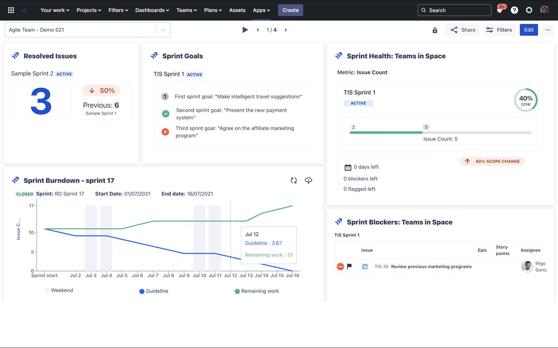
Purpose: Project Management and Agile Development
Uses in SafeRoute AI
- Sprint planning
- Task assignment
- Bug tracking
- Progress monitoring
- Project scheduling
Advantages
- Better team collaboration
- Organized workflow
- Faster issue resolution
- Easy project tracking

B. Figma

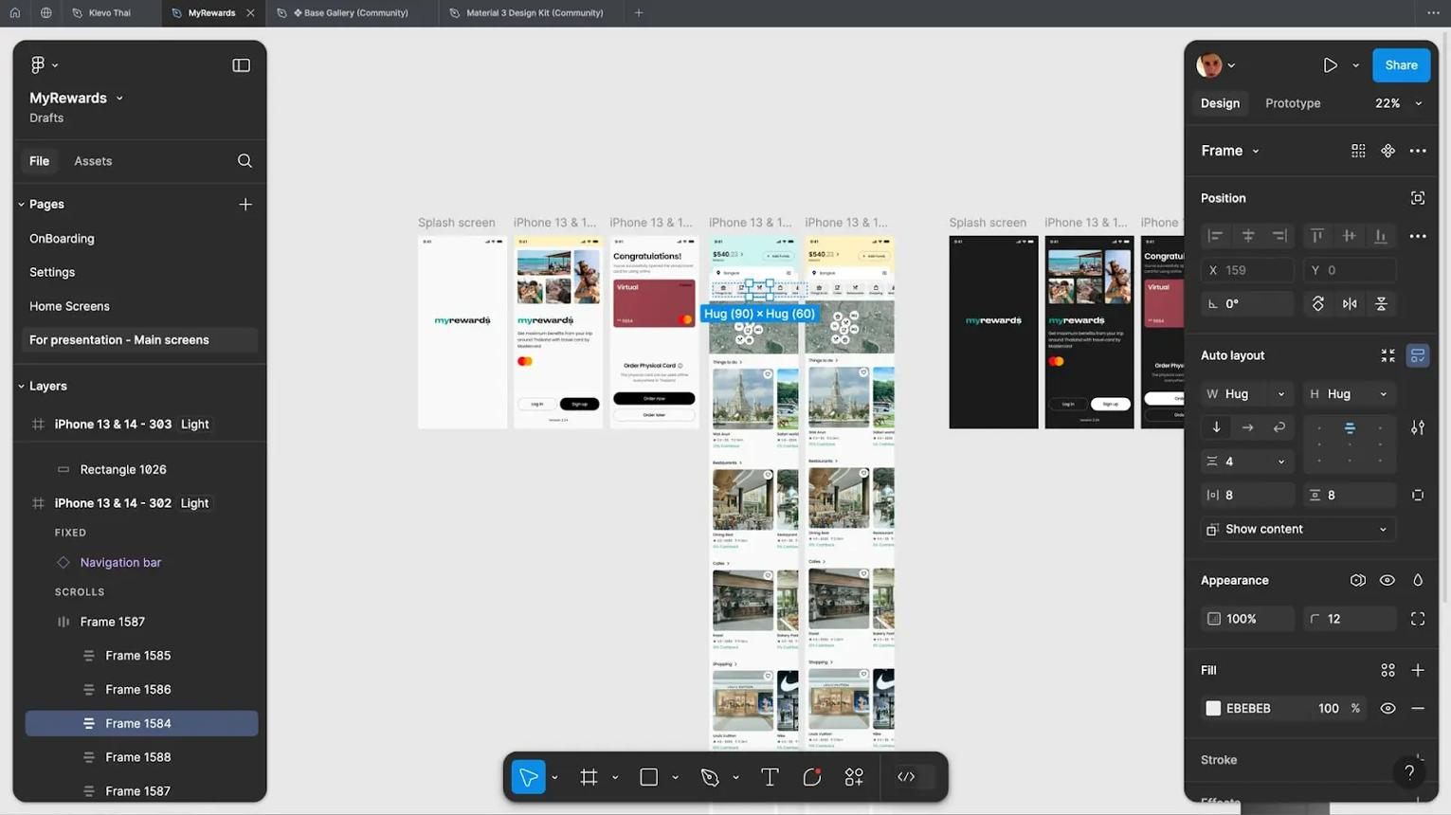
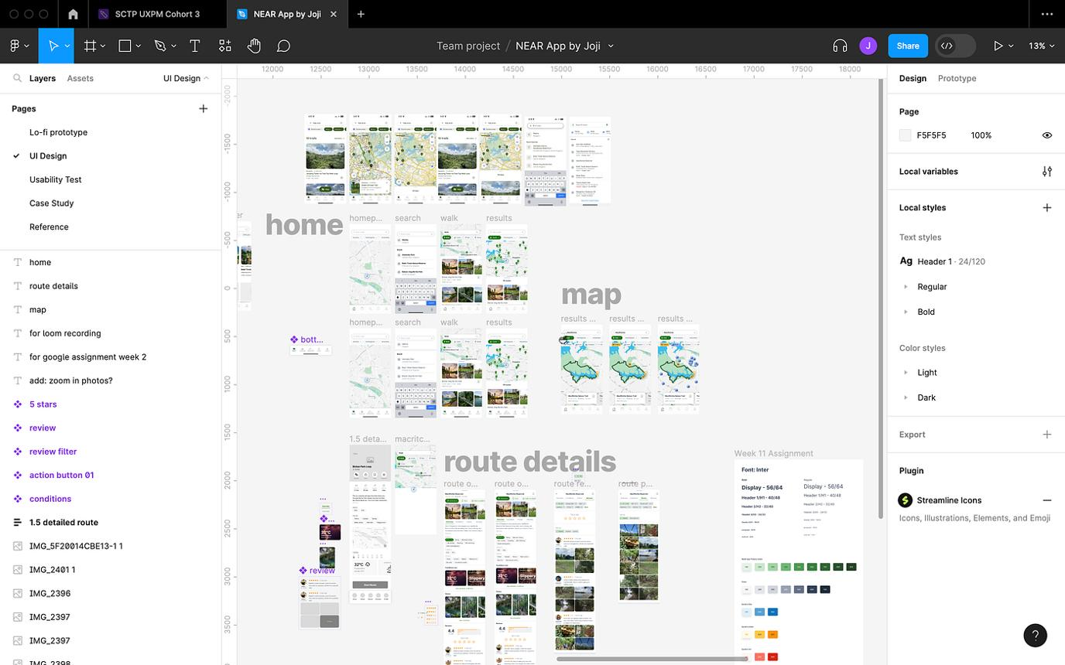


Purpose: UI/UX Design and Prototyping
Uses in SafeRoute AI
- Mobile app interface design
- Wireframe creation
- Interactive prototypes
- Screen design for login, dashboard, and alerts
- Team collaboration
Advantages
- Easy-to-use interface
- Real-time collaboration
- High-quality UI design
- Faster prototyping

14. Assumptions
- Users have smartphones with GPS.
- Internet connectivity is available.
- The camera captures clear road images.
- Users grant location permissions.
- AI model is trained with sufficient road hazard data.

15. Constraints
- Poor internet connectivity may delay alerts.
- Low-quality cameras reduce detection accuracy.
- Heavy rain or fog may affect AI performance.
- GPS inaccuracies can impact navigation.
- Cloud service availability is required.

16. Conclusion
SafeRoute AI is an intelligent road safety system that combines Artificial Intelligence, Computer Vision, GPS, and cloud technologies to detect road hazards and provide real-time alerts. The system helps drivers avoid dangerous roads, reduces accidents, and supports road maintenance authorities by providing accurate hazard information. Implementing SafeRoute AI can contribute to safer transportation and smarter cities.

17. References
- Ian Sommerville, Software Engineering, 10th Edition, Pearson.
- Roger S. Pressman & Bruce R. Maxim, Software Engineering: A Practitioner's Approach, 9th Edition, McGraw-Hill.
- Joseph Redmon et al., "YOLO: You Only Look Once: Unified, Real-Time Object Detection," CVPR.
- OpenCV Documentation – https://opencv.org
- TensorFlow Documentation – https://www.tensorflow.org
- Google Maps Platform Documentation – https://developers.google.com/maps

